Arunima Sinha is not just another mountaineer.. She is the **first female** **amputee to climb Mount Everest and the first Indian amputee to climb the huge Mount Everest.**

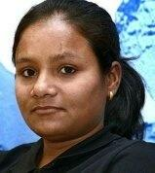

​  
​  
​  
  
  
*She was a national level volleyball player who was pushed from a running train by thieves in 2011 while she was resisting them. As a result one of her legs had to be amputated below the knee. She boarded the Padmavat Express train at Lucknow for Delhi on 11 April 2011, to take an examination to join the***CISF** *. She was pushed out of a general coach of the train by thieves wanting to snatch her bag and gold chain. Recounting the incident, she said*

I resisted and they pushed me out of the train. I could not move. I remember seeing a train coming towards me. I tried getting up. By then, the train had run over my leg. I don't remember anything after that.

*Immediately, as she fell on the railway track, another train on a parallel track crushed her leg below the knee. She was rushed to the hospital with serious leg and pelvic injuries, and lost her leg after doctors amputated it to save her life.*  
*While still being treated in the All India Institute of Medical Sciences, she resolved to climb Mount Everest***,** She was inspired by cricketer **Yuvraj Singh,** *who had successfully battled cancer, "to do something" with her life. She excelled in the basic mountaineering course from the Nehru Institute of Mountaineering, Uttarkashi, and was encouraged by her elder brother Omprakash to climb Everest* with a **prosthetic leg**, which was arranged by raising funds with the help of a swami of **Ramakrishna Mission**, Vadodara.

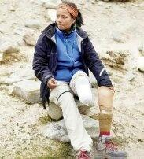

​  
​  
​  
  
  
On 1 April 2013, Sinha and **Susen Mahto**, a TSAF instructor, who had together climbed Mount Chhamser Kangri (6622 meters) in 2012 under the guidance of Bachendri Pal, started their ascent of Mount Everest. After a hard toil of 17 hours, Sinha reached the summit of Mount Everest at 10:55 am on 21 May 2013, as part of the Tata Group-sponsored Eco Everest Expedition, becoming the first female amputee to scale Everest. She took 52 days to reach the summit.

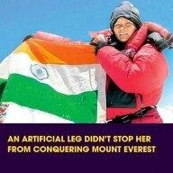

​  
​  
​  
  
  
Arunima Sinha is now dedicated towards social welfare and she wants to open a free sports academy for the poor and differently-abled persons. She is donating all the financial aids she is getting through awards and seminars for the same cause. The academy would be named Pandit Chandra Shekhar Vikalang Khel Academy.  
She has written a book "Born again on the mountain", launched by Prime minister of India Narendra Modi in December 2014.  
She was awarded Padma Shri, the fourth highest civilian award of India, in 2015.